Program 1 on Greatest Common Divisor (GCD)

CSC 2400, Fall 2021

# PART A – FIND GCD USING EUCLID’s ALGORITM

## Description

Euclid’s Algorithm solves the problem of finding the greatest common divisor of two non-negative, non-zero integers. You will create a program that will calculate the greatest common divisor of two integers based on Euclid’s Algorithm.

## Specifications

* Your source code should be contained in a single file and should be named your TTU email address excluding the “@students.tntech.edu” and an underscore and an ‘A’ to indicate part A (example: acrockett_A.cpp).
* Write a C++ program to find the greatest common divisor of two numbers m and n based on Euclid’s algorithm.
* Your program should be able to calculate the greatest common divisor for all inputs for which it is defined; you may assume the input values can be stored in an int data type.
* Your program will take in two **command arguments** specifying the value of m and n, and will write to standard output the text “gcd([m],[n]) = [v]” where [m], [n], and [v] are the values of m, n, and gcd(m,n), respectively.
  + I have provided a sample program called **commandLine.cpp** to show you how to implement a program that accepts command line arguments.
* In the case where the greatest common divisor is not defined, you will print the text “gcd([m],[n]) is undefined.” Refer to the sample output.

## SAMPLE OUTPUT

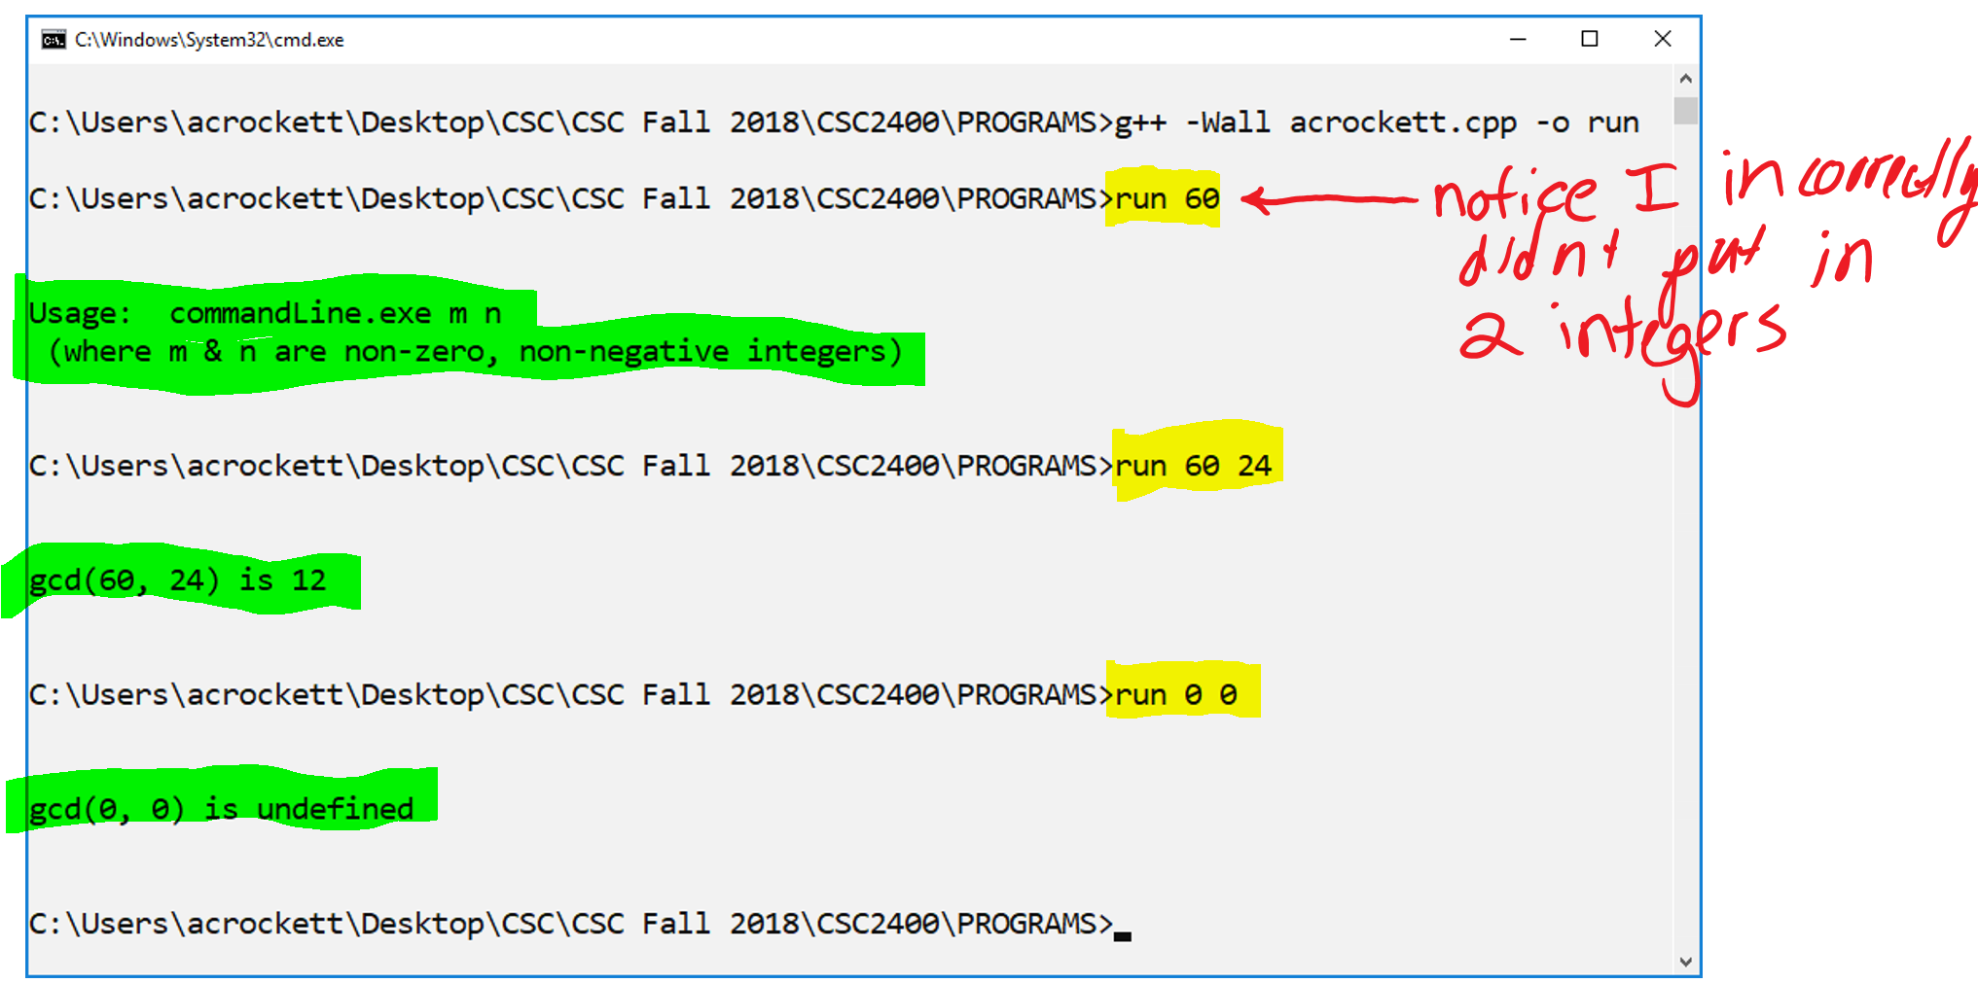

# PART B – FIND GCD USING Consecutive Integer Checking Algorithm

## Description

Consecutive Integer Checking Algorithm also solves the problem of finding the greatest common divisor of two non-negative, non-zero integers. You will create a program that will calculate the greatest common divisor of two integers based on the Consecutive Integer Checking Algorithm.

## Specifications

* Your source code should be contained in a single file and should be named your TTU email address excluding the “@students.tntech.edu” and an underscore and a ‘B’ to indicate part B (example: acrockett_B.cpp).
* Write a C++ program to find the greatest common divisor of two numbers m and n based on the Consecutive Integer Checking Algorithm.
* Your program should be able to calculate the greatest common divisor for all inputs for which it is defined; you may assume the input values can be stored in an int data type.
* Your program will take in two command arguments specifying the value of m and n, and will write to standard output the text “gcd([m],[n]) = [v]” where [m], [n], and [v] are the values of m, n, and gcd(m,n), respectively.
* In the case where the greatest common divisor is not defined, you will print the text “gcd([m],[n]) is undefined.” Refer to the sample output.

## Sample Output

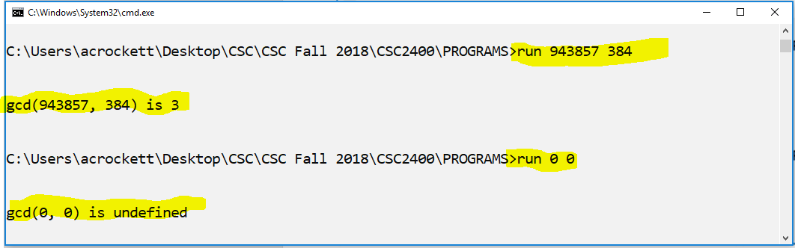

# Submission

**Zip** your two source files in one zip/compressed folder named your **username_prog1** (e.g. acrockett_prog1).

You will upload your submission to ilearn in an assignment folder named **Program 1**.

# Grading

The grading rubric is provided for you as a separate document. You will see from the rubric that you are allowed to turn in the program up to two days late (with a reduced grade).